FIVE GREAT HOME Cleaning TIps
  - Doing the Best Job the Easy Way!
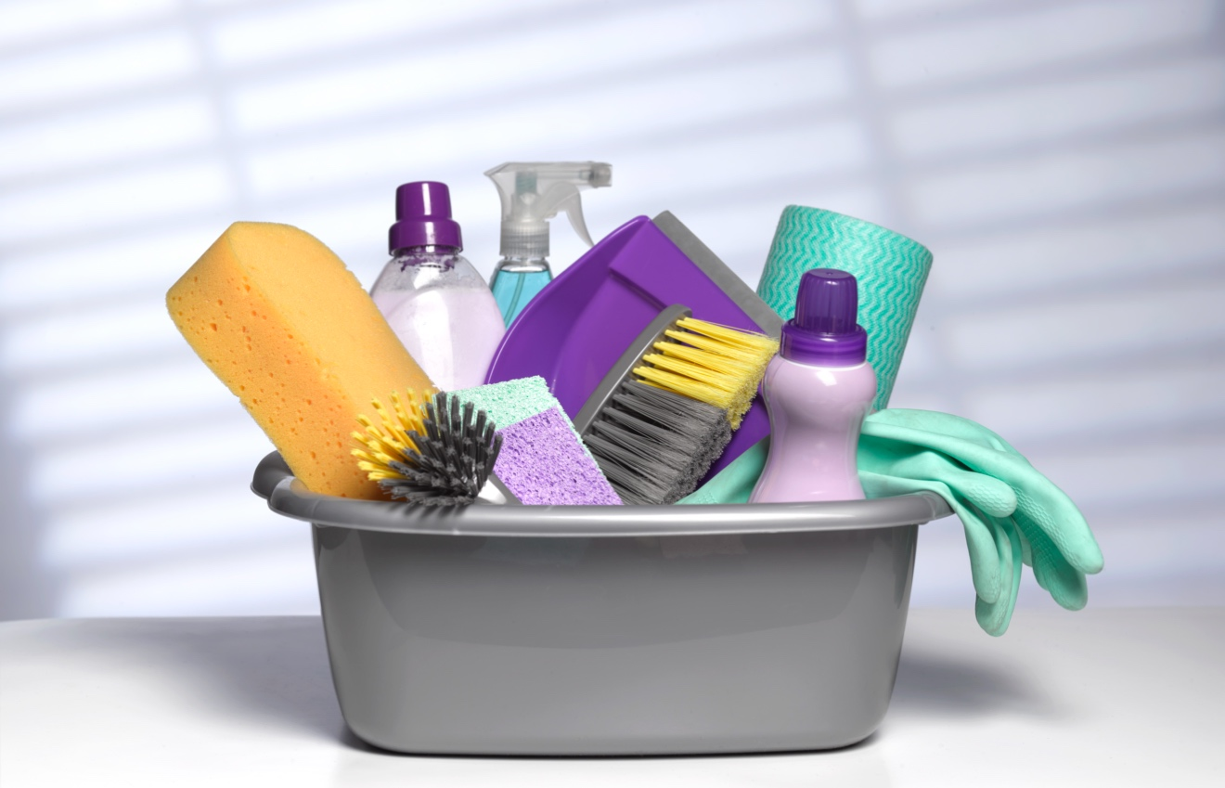
Jeff Cross

TAble of
ContentS
The Basics of Vacuuming 1

The Nooks and Crannies 1

The Battle Against Garbage Can Odors 3

Be a Dust Handler 4

Organizing & Cleaning the Bathrooms 5

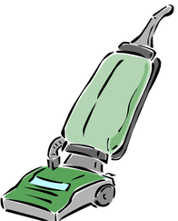The Basics of Vacuuming
If you have carpet or rugs, you have a vacuum cleaner. A vacuum is absolutely necessary to keep your valuable carpet and rugs clean of particulate or dry soil.
While vacuuming may seem like a basic housekeeping chore and simple to do, the biggest challenge is getting out the vacuum and actually putting it to use.
Frequency - How often you vacuum depends on the size of your family, and this includes pets. As a general rule, you should vacuum the main areas in your home, such as the living room, hallways, and other high traffic areas, one time each week per occupant.
For example, if you have four people and one dog in your family, vacuum five times per week, in those high traffic areas. For low-trafficked areas, once per week should suffice. This might seem extensive and perhaps unnecessary, but it keeps your carpet and rugs virtually free of dry soil buildup.
How to vacuum - You might be thinking, “You just plug it in and push it across the floor.” Which is basically what you do. The problem is how fast you move and how much overlapping you cover when running the vacuum.
While you may push the vacuum forward fast, slow down when you pull it towards you. This way the beater bar, if your vacuum has one, has a chance to work loose the soils. Also, overlap several inches from side to side so you have complete coverage of the floor.
Choosing the best vacuum - Quality matters when choosing a good vacuum cleaner. The cheaper ones at department stores may work fine for a while, but they quickly lose efficiency and often break down. Look at the reviews of any vacuum cleaner you are contemplating and spend a few more dollars on a superior model. Your carpet and rugs will be better off in the long run.
Choosing a vacuum with a beater bar is smart. Especially with thick pile carpet, it helps remove more dry soil. Some choose vacuum cleaners with a bagless option. If you use a vacuum cleaner with a bag, change it out when about half full, for maximum efficiency. Purchase plenty of replacement bags and have them on hand for this purpose.
Get with the pros - Cleaning companies, especially those who specialize in carpet and rug cleaning, can help you choose a quality vacuum. Get their input. After all, it pays to call a pro!

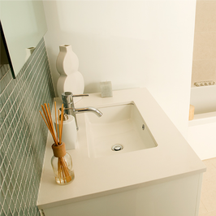 The Nooks and Crannies

Your home has plenty of areas for dirt and grime to hide. Locating them may seem easy. Cleaning them effectively is something else.
Most homeowners spend plenty of time sweeping, vacuuming, scrubbing, and cleaning areas that are obviously soiled and become soiled daily. There are areas that can really get gross in a short amount of time.
Your bathroom “work stations” — also known as vanity cabinets — are prime locations for soil buildup.
Let’s spend some time on how to tackle the chore of cleaning the bathroom vanity. One area of the home easy to ignore. After all, who looks in there besides the person searching out some face cream or hand lotion, among other items?
The buildup of residues can wreak havoc over time. Think of hairspray that you use daily and that ends up on the top of the cabinet. It may be easy to clean when fresh but give it 10 or more applications and you have a “goo” that’s not giving up its tenacious hold on the counter. This isn’t to even mention toothpaste and other necessary items that get smeared on the same surface.
Take some time each day — perhaps just a minute or so — to quickly wipe up any residues that land on the surface. Then, take some time each week — perhaps just five minutes or so — to open up any cabinet doors or mirrors that house storage behind them, remove all objects, and use a household cleaning solution to wipe down all surfaces. After a week, you will still be amazed at how much residue has built up in there. Imagine what could happen after a few months!
And once a month, give your entire bathroom a close scrutiny and look for all those nooks and crannies that can be the host of soil. This could be behind the toilet, in the corners of shower stalls, where the soap resides on the bathtub edge. All these areas could use a good scrubbing each month, if not more frequently.
And all this is besides the typical routine cleaning you no doubt give all your bathrooms.
But when you need some real help, from your favorite cleaning service, do the right thing. Give them a call today. After all, it pays to call a pro!

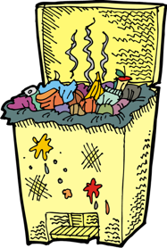 The Battle Against Garbage Can Odors
There’s nothing too exciting about garbage cans, except how you feel if you pull a full trash bag out and it bursts and spews all kinds of undesirables all over the kitchen floor.
If you have garbage, such as limp lettuce, fermenting flounder, greasy goat cheese, and much more, you will have odors from it.
Odors naturally occur from bacteria, which is what grows quickly on organic material. And then you have mold adding to the issue. All this fermenting in a dark, damp playground known as your garbage can.
Even if you have a secure trash can lid, the odors have a mind of their own and an evil intent to escape.
There are several things you can do to limit the effect of garbage can odors.
Take out the trash - It may seem simplistic, but most of us wait too long to take out the trash. A smell garbage can inside is terrible – the one outside waiting to be hauled away isn’t much better, but at least it is outside. Make it a practice to take out the trash before the bag is full.
Use quality scented bags - By quality, we mean bags that have a thicker mil rating, as they won’t break as easy. Yes, they cost more and use more plastic. Look at keeping the mil for your trash bag at 2 or above. The scented bags really do a great job hiding, not removing, odors. They mask bad odors and give you more time between taking out the trash before you start to notice odors.
Use baking soda - Baking soda is a typical household fixture. By sprinkling baking soda in the bottom of your garbage can and even in the bag, it helps to limit the odors caused by bacteria. It does this by absorbing odors instead of them being released into the air you breathe.
Give it a hosing - Like all things, garbage cans need to be cleaned. You might say, “I use bags!” but that doesn’t matter. Odors build up no matter what you do, and a good cleaning with baking soda or other cleaning products, and hosing or rinsing out the can, will help keep lingering odors at bay.
And like all things, quality cleaning of the surfaces in your home are better performed by the pros. Do the right thing, call your favorite cleaning company when you need help. After all, it pays to call a pro!

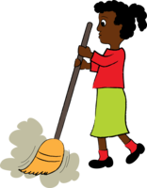 Be a Dust Handler
Dust. It’s everywhere. Want proof? Reach over to a cabinet top, a window sill… just about any surface. Rub your finger on them and see what you get.
While dust occurs naturally in homes and buildings, there are some practical steps you can take to minimize how much dust affects the cleanliness of your home but also how much it negatively affects health of your loved ones.
Exhaust fans - Talk about something you might never inspect, unless you think about it. Give it some thought now. In your bathrooms, look up at your exhaust fans — assuming you have them. Look closely. They are probably covered with dust and hair and other debris, and perhaps the circulation openings are completely clogged up. Use a vacuum to remove as much as you can, and when there is air flow into the fan, use some compressed air to finish the job. Loosening up the dust means the fan will move it on out.
Area rugs - While you vacuum your floors and area rugs on a scheduled basis, you never get as much dust out of area rugs than taking them outside and giving them a good “beating.” Of course, the area rug has to be of a size and weight you can handle. But if you get them outside, drape over a fence or patio chair, and go at them with a broom or tennis racket, you will get much more dust out of them than if you vacuumed alone.
High areas - Like your exhaust fans, other areas you might not inspect can be dust collectors. Think about your ceiling fans, trim around doors and windows, pictures and ornaments, any area above typical eyesight. Your favorite department store or online store will have a variety of dusting devices you can use. They also have products meant to, while you clean, attract dust, dander, and debris so you aren’t just moving it around. The main thing is to buy them and use them on a regular basis.
Maintenance - As with any task, performing what needs done on a schedule is important. Keeping a house clean and tidy is a task that never ends. From dusting to carpet cleaning, to hard floor care, and more, the best way to keep it all in perfect shape is to use a quality and professional cleaning service. After all, it pays to call a pro!

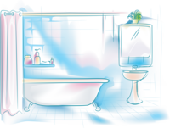 Organizing & Cleaning the Bathrooms
Besides the kitchen, your bathroom is one of the most popular and trafficked rooms in your home.
Keeping your bathroom organized, clean, and tidy can be a daunting chore. And your work increases tremendously if you have more than one. Many homes have several bathrooms. That’s a lot of cleaning and organizing to tackle, especially if you let too much time pass without giving them some attention. It’s easy to see several days, a week, even more pass without a close scrutiny of the condition of a bathroom—and then all of a sudden you are amazed how all the nastiness snuck up on you.
The way to tackle all of this is with a plan—a cleaning plan, which includes organizing all bathroom content as well.
Each day you should wipe down all surfaces that are frequently used, such as the countertop, faucet handles, the sink, even the toilet seat.
Every few days you should add in spraying the tub or shower with your favorite tub/tile cleanser and rinse it out completely. Scrub if necessary.
Each week, it’s time to get down to business. A thorough cleaning should take place, even more frequently if you have a large family. This means all surfaces are sprayed with cleanser, scrubbed and/or wiped down. The floors should be swept and mopped. Insides of toilets should be cleaned so all scaling and mineral deposits are removed.
And that’s just to keep everything clean. What about organizing the contents? Open up the drawers, cabinets, check the inventory of what is in your bathroom. You will be amazed at the number of toiletries, medications, cosmetics, lotions and potions you have amassed over the years. Many of them are no doubt expired, some by many years unless you have kept up with what you stock your bathroom with.
Take the time to look at expiration dates and start throwing out what has expired. Some products will last for years. Others just a few months. Even cosmetics have an expiration suggestion.
Also consider better organizing, using shelving or organizing products such as bins that can be stacked, to help you keep it all in its proper place.
And, of course, when you need some professional cleaning done in your home, whether routine cleaning or deep cleaning such as for your carpet, do the right thing. Call your favorite cleaning company. After all, it pays to call a pro!

